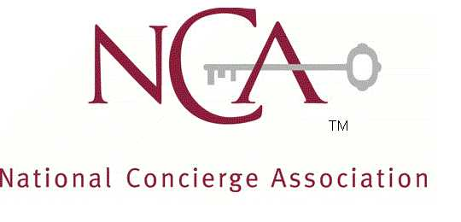

NCA 17th Annual Conference
“People, Purpose, Passion”
#ncahospitalitystars

San Antonio, Texas – August 13-15, 2015

Affiliate Showcase Event – Friday, August 14, 2015– Noon-3:00pm

The National Concierge Association (NCA) will hold its 17th Annual Conference at the Westin Riverwalk Hotel August 13-15, 2015. The Affiliate Showcase will take place at the International Center located on the Riverwalk, on Friday, August 14, 2015, from Noon-3:00pm.

This event is a must. You will be showcased to all our local concierges along with national members of the National Concierge Association. This is your opportunity to be face-to-face with the individuals who drive business to your venues. Many of you struggle to find time to network – well here is your chance.

2015 NCA Conference Affiliate Showcase fees:
Includes 6ft table w/ Linens, 2 chairs

NCA Affiliated business member: $125.00
Non-NCA Business: $375.00

Not a Member? Join Now and Save $50 on the Affiliate Showcase! Visit www.ncakey.org for membership information or email elizabeth@lonestarscelebrity.com

Free admission for all registered attendee’s. RSVP
$10 Admission for all non-industry guests of attendees at the door.

Please complete the attached form to be a part of the most spectacular networking event all year.

2015 NCA Conference Affiliate Showcase Registration Form

Please note: Set-up for tradeshow participants will take place at the International Center:
La Orilla Del Rio Ballroom
203 S. St. Mary's Street
San Antonio, Texas 78205
The exact time will be provided to advance paid participating businesses via advanced emailed notice. NCA 2015 Affiliate Showcase Registration fees are non-refundable.

Please type or print the following information:

Title of Business: ____________________________________________________________________

Check one: NCA member _________ Non-NCA Business _________

Contact: _______________________________________Title__________________________________

Phone: _______________________________________Fax___________________________________

Email: ________________________________ Website: _____________________________________

Please check all that apply to your Showcase Table, so the NCA can promote your business more effectively in our communication to all attendees leading up to the Conference:

______Food/Beverage ______Giveaways _______Raffle Item ______Other
Please provide additional information that you’d like us to promote:
_____________________________________________________________________________________________
_____________________________________________________________________________________________

Do you need any of the following for your table?

_________Electrical supply ________ Wi-Fi (additional charge may apply)

_________Other – please explain: ________________________________________________________

Thank you for your participation in the 2015 NCA Affiliate Showcase.

Fees for 2015 Affiliate Showcase (includes 6 ft table w/linen, 2 chairs:

NCA Affiliate Member: $125.00
Non-NCA Business: $375.00

Join Now and Save $50! Email us for more information on our membership

Preferred method of Payment: _______Check _______Credit Card (please provide additional information on the form provided or call Lennie Turpin at 210-827-0192)

Mail checks with completed form to
2920 Idaho Avenue North
Minneapolis, MN. 55427

Questions? Email elizabeth@lonestarscelebrity.com Please feel free to pass this offer onto other industry related businesses who may wish to participate.

